Kim Đồng primary school
Student’s name:……………………………
Class: 5/1

REVIEW WEEK 34
PART 1: Complete the crossword
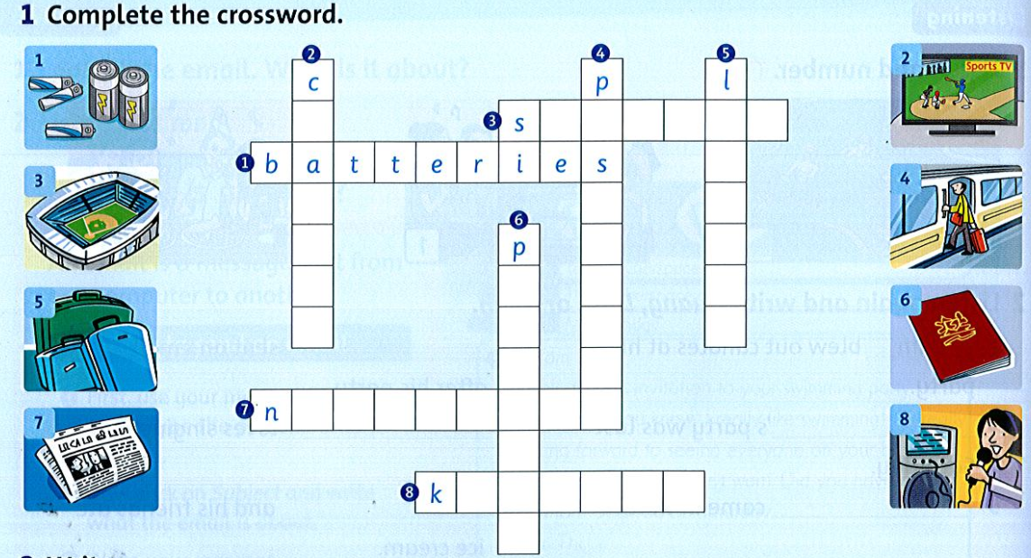
PART 2: Write
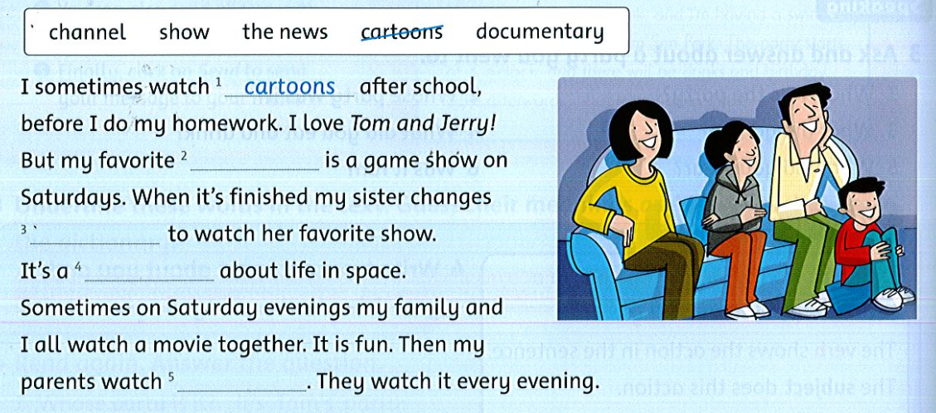

PART 3: Circle and answer
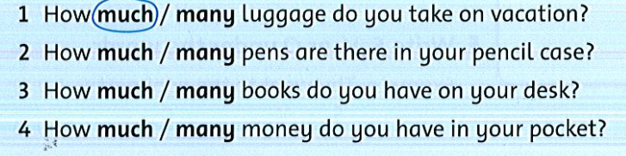
PART 4: Write
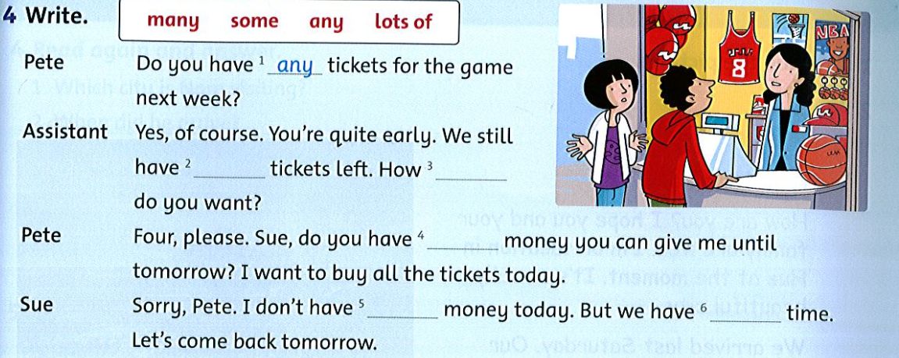
PART 5: Write
